**CSI3670**

**Winter 2019**

**Lab 5a**

**Joining Active Directory**

**Synopsis:**

This isn't a full lab, but the start of one. First, you'll join the AD setup in our local VM environment (vcenter6.secs.oakland.edu).

**Update your DNS server to join csi3670.cto**

From the Start Menu, search for ‘View Network Connections.’ Open that up. Right-click on ‘Ethernet’ and click Properties. Click on Internet Protocol Version 4 (TCP/IPv4) and click Properties.

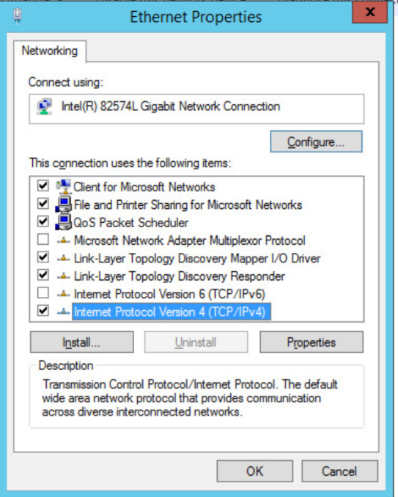

Change the DNS server to use the following addresses:

141.210.25.41

141.210.25.83

These are the two master domain controllers for this network.

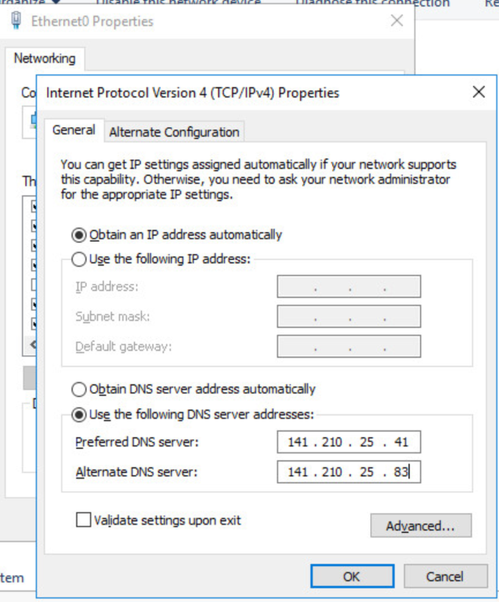

Then click the Start Menu again, right click on This PC and Properties. Under the Computer Name, domain, and workgroup settings, click ‘Change Settings.’

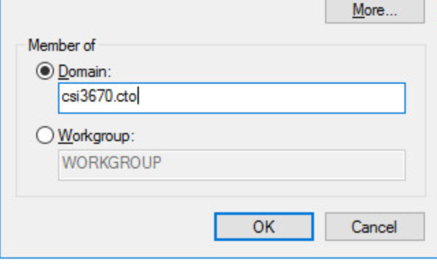

Click the ‘Change...’ button. Change the ‘Member of’ field to be csi3670.cto. Clicking OK will ask for a username/password, give it a username of CSI3670Temp@csi3670.cto and password of Temp12345.

From here on out, you will log into these machines as:

**your-last-name@csi3670.cto**

Feel free to change your password, but the default is Temp12345

**For the team member nominated as main domain controller:**

Currently, we have an existing forest at **csi3670.cto** that is owned by me, and you’ll be joining that forest with your group domain. You get to create your team’s domain. Make your domain your **team name** that you each agreed upon (note that the characters are limited --- no spaces, special characters, etc.). If only one of you has a computer, whoever is running the machine can be automatically promoted to this position. Don’t worry, it's not that bad. Promote your server to be a domain controller. This machine needs to have Active Directory Domain Services installed, so add the Role as you did for one of the prior homeworks. **Again, only the teammate who agreed to be the domain controller needs to do this**.

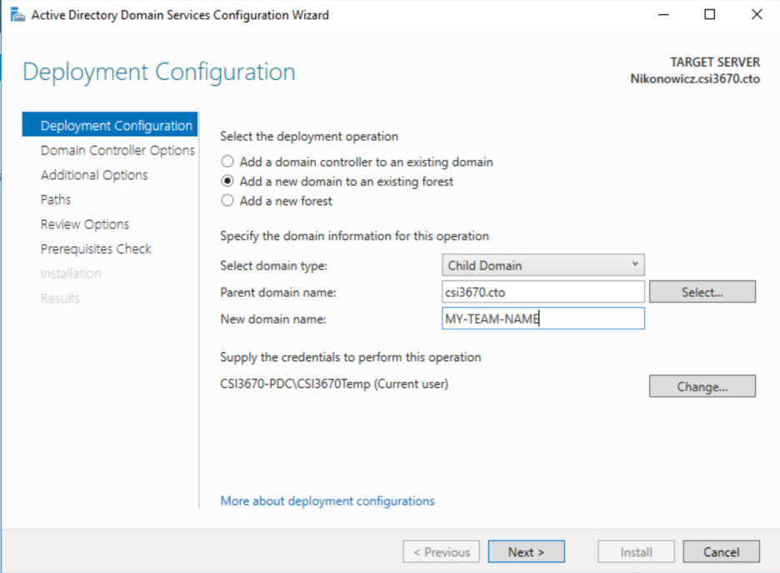

Click ‘Change...’ next to *Supply the credentials to perform this operation*, as you need admin rights to make changes.

Give it a username of CSI3670Temp@csi3670.cto and a password of **Temp12345**. This is a general username/password combo that will give you that access and be changed after this lab.

Moving forward give it a domain services recovery password of **Temp12345**.

Click Next until you get to the NetBIOS domain name. Verify that it seems correct and click next.

Hit next until you get to actual installation, then click Install.

**This should be done by Monday, March 11th by 11:59pm. How I will grade it is that I will try to add each of your servers to my Server Manager, and will check to see that all of your subdomains have been added.**